Wake Forest NCORP Research Base
Bi-Weekly Broadcast
January 29, 2021
WAKE NCORP Website: https://wakencorp.phs.wakehealth.edu/

ANNOUNCEMENTS

WAKE NCORP WEBSITE UPDATE:

When accessing the Wake NCORP Website (https://wakencorp.phs.wakehealth.edu/) please use the Google Chrome browser (https://www.google.com/chrome/). Documents, guides, and training videos work best in this browser.

Study Updates

- WF-30917CD Telehealth – A Stepped-Care Telehealth Approach to Treat Distress in Cancer Survivors
  - Amendment 5 activated on January 13, 2021.
  - The editable versions of the following letters are posted to the WAKENCORP website under FAQs and Resources for Telehealth.
    - Appendix 05a: Baseline Self-Report Measures Letter Template
    - Appendix 10a: Expectancy Rating Scale Letter Template (High and Low Intensity)
    - Appendix 12a: Week 13 Self-Report Measures Letter Template
  - The protocol lists the support document names with “SD” at the beginning of the document name. However, the documents were not uploaded to CTSU with “SD” included as part of the document name. A crosswalk has been created and uploaded to the WAKENCORP site under FAQs and Resources within the Telehealth protocol section to ensure you reference the correct document(s).

If there are any questions regarding WF-30917CD, please contact NCORP@wakehealth.edu.

- WF-1801 Ramipril - A Single Arm, Pilot Study of Ramipril for Preventing Radiation-Induced Cognitive Decline in Glioblastoma (GBM) Patients Receiving Brain Radiotherapy

Amendment #5 has been approved and scheduled for release Monday, February 1, 2021.
Changes with this amendment include:
  - Off Study/Off Agent Form was separated into two different forms and the protocol sections that refer to these documents were updated.
  - The shipping address for samples for DNA isolation was updated.
  - A Special Broadcast will be distributed when the amendment is released. If there are any questions regarding WF-1801, please contact NCORP@wakehealth.edu. Attn: WF-1801

An important reminder regarding which Adverse Events (AEs) should be reported and which should not be reported per the current approved WF-1801 protocol.
    - Grade 1 and 2 AEs will not be collected.
    - All expected AEs grade 3 and unexpected that are unrelated or unlikely AEs grade 3 will also not be collected.
    - All expected AEs grade 4 will also not be collected.
    - All other adverse events will be reported to the Wake Forest NCORP Research Base using REDCap Adverse Event Reporting and CTEP-AERS, if required per protocol. Please refer to Section 10.0 of the current approved protocol, which includes this table below for additional details.

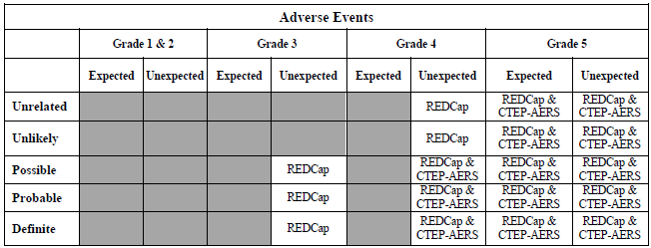

- WF-97415-UPBEAT - Understanding and Predicting Breast Cancer Events after Treatment (UPBEAT)

  - MRI, ECHO, and CPET Reimbursements
Please remember to submit reimbursement forms for MRI, Echocardiograms, and CPETs for this study. The reimbursement form can be found on the WAKENCORP website (https://wakencorp.phs.wakehealth.edu/) in the Open Protocol Documents section, under the “97415 – UPBEAT” heading. The completed form and invoice should be submitted to Stacey Belton (sbelton@wakehealth.edu). Reimbursements cannot be processed until the CRF has been completed in REDCap.
  - Please do not ship biospecimen samples on Friday. Store frozen samples to ship the following Monday as these will thaw if delivered over the weekend.

- Accruals as of January 29, 2021

Open Studies | Name | Enrolled (Patients) | Target (Patients) | Enrolled (Non-Patients) | Target (Non-Patients)
WF-97115 | Acupuncture | 224 | 240
WF-97116 | Remember | 270 | 276
WF-97415 | Upbeat | 292 | 1000
WF-1801 | Ramipril | 38 | 75
WF-1802 | PCW | 91 | 220
WF-1806 | M&M | 31 | 300
WF-1901 | IMPACTS | 0 | 456 | 0 | 40
WF-30917CD | Telehealth | 43 | 90
WF-1804CD | AH-HA | 32 | 600 | 5 | 40
WF-1805CD | HN STAR | 0 | 350 | 22 | 140

