**Wake Forest NCORP Research Base**

**Bi-Weekly Broadcast**

**June 22, 2020**

**WAKE NCORP Website link** <https://wakencorp.phs.wakehealth.edu/>



**ANNOUNCEMENTS**

**The Wake Forest NCORP RB ANNUAL MEETING FOR 2020 will be Virtual**

In light of the ongoing COVID-19 pandemic and current expectations of its long lasting effects on travel and in-person gatherings, Wake Forest NCORP RB leadership has examined the feasibility and advisability of hosting our scheduled in-person group meeting in October, 2020. After consultation with NCI/DCP NCORP leadership and considering the potential extension of current Wake Forest institutional guidelines on travel and in-person meetings during the fall and winter, we have decided to switch to a condensed virtual meeting format for 2020. We are actively developing the modified agenda for this meeting in an effort to maintain as many of the positive features of our typical meeting as possible including updates on active and planned studies, new concepts under consideration, data management and site coordination discussions, and, most importantly, opportunities for informal interactions with study PI’s, WF team members and colleagues from other NCORP sites.  We are currently leaning towards meeting in the afternoons on Thursday Oct. 29 and Friday Oct. 30 in order to allow NCORP sites in all time zones to participate. The meeting will also likely be a combination of some prerecorded brief presentations (to minimize connectivity disruptions as multiple study teams potentially in many different locations will need to present), each of which will be followed immediately by “live” question and answer periods. We also hope to have one or more live panel discussions. We welcome your suggestions on other approaches to virtual meetings that you have been a part of that have been particularly engaging and successful.  We will provide more information regarding this meeting including registration instructions and CME options in the coming weeks to months.  Thanks for working with us during what we hope is a temporary change in how we interact with our colleagues.

**DEADLINE FOR SUBMISSION – JUNE 24, 2020 - Funding Opportunity for Pilot Projects**

The Wake Forest NCI Community Oncology Research Program (NCORP) Research Base seeks applications for meritorious pilot projects that will generate preliminary data in support of future NCORP cancer control and cancer care delivery research (CCDR) protocols. Areas of interest include symptom intervention and surveillance, health outcomes research, new approaches to cancer care delivery, and implementation of evidence-based practice in cancer care. Wake Forest NCORP priorities include cancer- and treatment-related cardiotoxicity, neurocognitive toxicity, cancer survivorship, implementation science, and cancer caregiving. Investigators may request up to $75,000 for a one year pilot project (this does need to include any indirects in this amount).

Additional information can be found on the WAKE NCORP website, Open Protocols, Pilot Awards Information Tab or by contacting [NCORP@wakehealth.edu](mailto:NCORP@wakehealth.edu) for the full RFA information.

**NEW – Samples for DNA Isolation – Shipping Address Change**

The address for samples to be shipped for DNA isolation on the two studies listed below has changed. Please request new pre-paid shipping labels by sending your Site’s contact name and address to [NCORP@wakehealth.edu](mailto:NCORP@wakehealth.edu). If you have a sample to send before you receive your replacement labels, you may still use your current labels as we will be monitoring the other address for packages.

* WF 97116 Remember
* WF 1801 Ramipril

The new address is: WF NCORP Biospecimen Lab

Wake Forest Biotech Place

575 Patterson Avenue, Suite 240-250

Winston-Salem, NC 27101

Phone: (336) 716-2581

Missed samples can be collected at any future clinical or study visit as it reflects a germline process that will not be affected by treatment.

**Upcoming Holiday (July 4th) Hours**

|  |
| --- |
| **McKesson: Clinical Research Services Closed July 3, 2020**  In observance of Independence Day, McKesson’s Clinical Research Services will be closed **Friday, July 3, 2020.**  We will resume regular business hours on Monday, July 6, 2020.  Our regular business hours are Monday through Friday, 9 am to 6 pm ET.  Please take this information into consideration when placing your orders **prior to Independence Day.**   * If temperature-controlled or non-temperature-controlled product is required before the holiday, orders must be placed by **Thursday, July 2** prior to 2 pm ET. * Orders received by **Thursday, July 2** prior to 2 pm ET will be delivered on **Friday, July 3**. **Please specify when ordering if your site will be open on Friday, July 3 to receive product.**   Due to the influx of shipments around the holidays, carrier delays may occur.  Please plan your orders accordingly.  If you have questions regarding the shipment schedule, please contact our Clinical Research Services team at 800.693.4906, or via email at [clinicalresearchservices@mckesson.com](mailto:clinicalresearchservices@mckesson.com).  **Wake Forest NCORP Research Base Office Hours** – Our offices will be closed Friday, July 3, 2020 and will resume regular business hours on Monday, July 6, 2020. |
|  |
|  |

**WF NCORP RB Quarterly WebEx Slides Posted** – If you missed our interesting Quarterly WebEx last week with the latest updates, you can review the slides on our website at <https://wakencorp.phs.wakehealth.edu/>

Click on Open Protocols and then on the tab entitled NCORP Quarterly Presentations.

**STUDY UPDATES:**

* **WF 97115 – ACUPUNCTURE - *A Phase III Prospective Randomized Trial of Acupuncture for Treatment of Radiation-Induced Xerostomia in Patients with Head and Neck Cancer***

**EFFECTIVE IMMEDIATELY:**  The MD Anderson lab is open to receive saliva samples on Tuesday, Wednesday, Thursday and Friday. During the day, the working schedule is reduced due to COVID-19 precautions. Since the working schedule is reduced, it is more critical to do the following two steps when shipping saliva samples:

1. Select the delivery method that will ensure that the samples arrive to MD Anderson **before 10:30 AM the next day.**
2. Email Dr. Pelying Yang ([pyang@mdanderson.org](mailto:pyang@mdanderson.org)) and Jibin Ding ([jding@mdanderson.org](mailto:jding@mdanderson.org)) on the day that you ship samples, including the shipment **Tracking Number**, so that they are aware and can coordinate receiving the samples from our shipment receiving dock on the next day.

These are the same steps that MD Anderson Lab had you do before and thank you for doing them. But, due to the reduced working schedule at the MD Anderson Lab, if these two steps are not completed, it becomes highly likely the samples will not be processed in time so it is more critical now to do these two steps.

* **WF 1804CD – AH-HA**

The CCDR study (WF-1804CD: Assessing Effectiveness and Implementation of an Electronic Health Record (EHR) Tool to Assess Heart Health among Survivors (AH-HA)) is beginning a second phase of site recruitment. Briefly, this study will enroll 12 NCORP affiliates/sub-affiliates in a cluster, randomized controlled trial to study the effectiveness of an EHR-based intervention (the AH-HA tool) to improve cardiovascular disease management among patients in survivorship care.

Affiliates/sub-affiliates must use the EPIC EHR to be eligible to participate. Below is a brief schema of the study design. Currently approved study materials are located on the Wake Forest NCORP website.

An amendment is under review to expand remote data collection and include virtual visits. To express interest in the study or to request more information, please contact Eleanor Davidson ([ecdavids@wakehealth.edu](mailto:ecdavids@wakehealth.edu)).

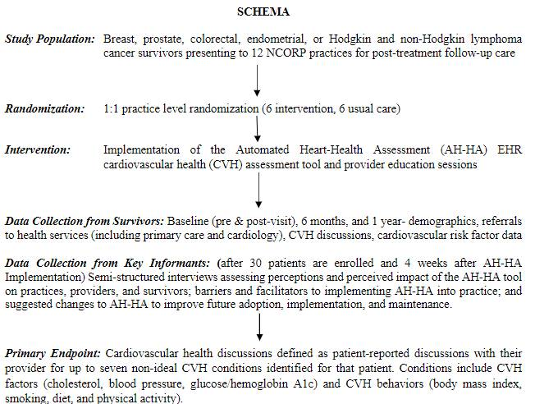

* 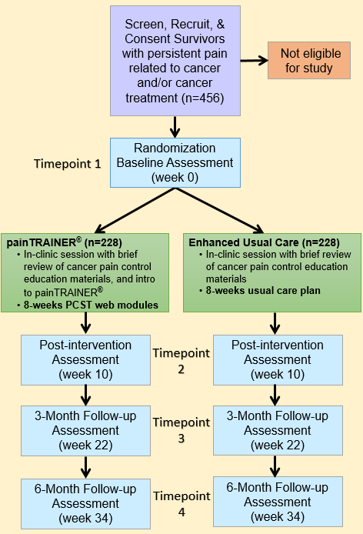**COMING SOON - WF 1901 – IMPACTS - *Internet-delivered Management of Pain Among Cancer Treatment Survivors***
  + This is a parallel group randomized controlled, prospective study that examines the effect of an Internet-based PCST program, painTRAINER®, on pain severity and pain interference among adult cancer survivors experiencing persistent cancer-related pain. The study also explores the effects of painTRAINER® on opioid/analgesic medication use, health-related quality of life, pain management self-efficacy and various other factors relevant among populations with persistent pain (*i.e.*, fatigue, sleep, emotional distress, positive affect, pain impact, perceived cognitive problems, and cognitive performance), as well as qualitative assessments of participants experiences with pain and the intervention.
  + There will be two arms:

1) Enhanced Usual Care; 2) painTRAINER® arm

* + Study Sample Size: n = 456 (228 per arm)
  + Duration: 34 weeks
  + Anticipated Open Date: By September 1, 2020
  + **For additional information**, check out our website for a watermarked, not activated protocol. Click on open protocols and look for the tab entitled WF 1901 IMPACTS
  + ***If you are interested in participating, please contact us at NCORP@wakehealth.edu***

**General Site Email Address**: If your site has a general email address that you would like for WF NCORP RB to use in order to assure that your site gets all of the Bi-Weekly and Special Broadcasts, please send that email along with your site name and CTEP ID to [NCORP@wakehealth.edu](mailto:NCORP@wakehealth.edu).

**General WF NCORP RB Biospecimen Lab Management:**

* Please request your lab kits before you run completely out of kits. This will ensure that there will be no delay in getting samples shipped to the Biospecimen Laboratory.
* Please do not ship samples on Thursday or Friday so that samples will not arrive on the weekend.

**General Data Management** – **How do I find my REDCap data queries?**

*For studies using REDCap data entry (WF-20817CD-OASIS, WF-97415-UPBEAT, WF-1801-RAMIPRIL, WF-1802-PCW and WF-1806 – M&M) please click the “Resolve Issues” link on the left side menu to check for any open data queries*

*Please email* [*NCORP@wakehealth.edu*](mailto:NCORP@wakehealth.edu) *with any questions you may have regarding the Bi-Weekly information.*

* **Accruals as of June 12, 2020**

|  |  |  |  |
| --- | --- | --- | --- |
| **Open Studies** | **Name** | **Enrolled** | **Target** |
| WF 97115 | Acupuncture | 212 | 240 |
| WF 97116 | Remember | 251 | 276 |
| WF 97415 | Upbeat | 251 | 1000 |
| WF 10217 | Ways | 206 | 220 |
| WF 30917CD | Telehealth | 35 | 90 |
| WF 1801 | Ramipril | 31 | 75 |
| WF 1802 | PCW | 76 | 220 |
| WF 1804CD | AH-HA | 0 | 624 |
| WF 1806 | M&M | 18 | 300 |