Wake Forest NCORP Research Base
Special Broadcast
Date February 27, 2020

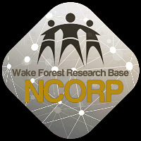

WF 97115 – Acupuncture Amendment 14, Protocol Version Date 12/26/2019, Release 2/28//2020
The WF NCORP Research Base study entitled A Phase III Prospective Randomized Trial of Acupuncture for Treatment of Radiation-Induced Xerostomia in Patients with Head and Neck Cancer has been amended. The amendment will be released on 2/28/2020.

Changes made with this amendment include:
    - Retracting the REDCap patient registration process allowing sites to continue to register all patients using the Wake Forest NCORP Research Base website enrollment system, CCRBIS.
      - Amendment 13 was approved, but not activated/released.
      - With Amendment 13, the registration portal was changed from CCRBIS, to REDCap.
      - With the release of Amendment 14, patient registration in REDCap will be retracted and registration will continue as always in CCRBIS. The other change from Amendment 13 (clarification of Inconsistencies in the baseline schedule of events) will be implemented.
      - All documents will be posted on the Wake NCORP website. You will need to submit both the Amendment 13 and Amendment 14 to your local IRB for approval.
      - Please make sure you obtain your local IRB approval and send this approval to NCORP@wakehealth.edu.

