Wake Forest NCORP Research Base
Special Broadcast
July 1, 2020
WAKE NCORP Website link https://wakencorp.phs.wakehealth.edu/

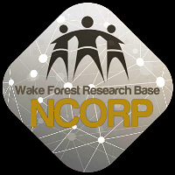

ANNOUNCEMENTS

Upcoming Holiday (July 4th) Hours
McKesson: Clinical Research Services Closed July 3, 2020

In observance of Independence Day, McKesson’s Clinical Research Services will be closed Friday, July 3, 2020. We will resume regular business hours on Monday, July 6, 2020.

Our regular business hours are Monday through Friday, 9 am to 6 pm ET.

Please take this information into consideration when placing your orders prior to Independence Day.
- If temperature-controlled or non-temperature-controlled product is required before the holiday, orders must be placed by Thursday, July 2 prior to 2 pm ET.
- Orders received by Thursday, July 2 prior to 2 pm ET will be delivered on Friday, July 3. Please specify when ordering if your site will be open on Friday, July 3 to receive product.

Due to the influx of shipments around the holidays, carrier delays may occur. Please plan your orders accordingly.

If you have questions regarding the shipment schedule, please contact our Clinical Research Services team at 800.693.4906, or via email at clinicalresearchservices@mckesson.com.

Wake Forest NCORP Research Base Office Hours – Our offices will be closed Friday, July 3, 2020 and will resume regular business hours on Monday, July 6, 2020.

