Wake Forest NCORP Research Base
Bi-Weekly Broadcast
February 18, 2020
WAKE NCORP Website link https://wakencorp.phs.wakehealth.edu/

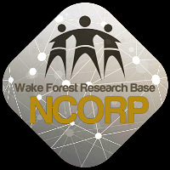

NEW TRAVEL AWARDS FOR PRIORITY ACCRUALS in 2020:
The Wake Forest NCORP Research Base will offer travel awards to cover two nights hotel accommodations at the Wake Forest NCORP 2020 Annual Meeting for NCORP Community and M/U Community sites that accrue the highest number of racial/ethnic minority (WF 10217 & WF 1802) and rural patients (WF 30917CD), see below. Two travel awards per study will be offered for each of the following protocols:
- TELEHEALTH: WF 30917CD (all accruals between 1/1/2020 and 8/31/2020)
- PCW: WF 1802 (all accruals to AA and/or low-income strata between 1/1/2020 and 8/31/2020)
- WAYS: WF 10217 (all accruals between 1/1/2020 and 5/31/2020)

STUDY UPDATES:

- NEW – WF 1805CD HN Star – Implementation and Effectiveness Trial of HN-STAR
  - An Introductory WebEx will be held February 25 at 3pm. If you did not receive a WebEx invitation, please contact us at NCORP@wakehealth.edu.

- WF-1803CD-CAREGIVERS
***Complete the rostering survey for enrollment by March 18, 2020***
  - If you would like to participate in this study, please start the rostering process before this date. If you have any questions regarding this process, please contact NCORP@wakehealth.edu

WF1803CD - Practice Group Rostering and Component/Subcomponent Eligibility & Registration

  - Data collection for this study will end on or around April 30, 2020.

- WF 1801 Ramipril – A Single Arm, Pilot Study of Ramipril for Preventing Radiation-Induced Cognitive Decline in Glioblastoma (GBM) Patients Receiving Brain Radiotherapy
  - Chemotherapy drugs should not be reported on the concomitant medications form in REDCap. There is a place to report if all temozolomide was taken as prescribed for that time period on the weekly assessments during titration and during Radiation Therapy (RT).

- WF 1806 M&M – Myopenia and Mechanisms of Chemotherapy Toxicity in Older Adults with Colorectal Cancer.
Looking for a study for older patients? What about Spanish speaking patients?

Who can participate?
  - Older adults (age ≥ 65y) with either
    - Newly diagnosed metastatic CRC or
    - newly recognized metastatic recurrence of CRC greater than 1 year from completion of treatment for non-metastatic CRC
  - Planning to undergo 1st line 5-FU based chemotherapy as monotherapy or combination.
What is involved?
  - 3 Time points: Baseline, Time point 1 & Time point 2
  - Capturing data on routine treatment, labs & Grade 3 or higher Toxicities.
  - Brief physical testing – SPPB and HGS
  - Patient will complete paper surveys at each timepoint (approx. 20 mins)
  - Submission of patient blood for DNA markers & routine CT images
  - Survival status captured at 1 year from diagnosis
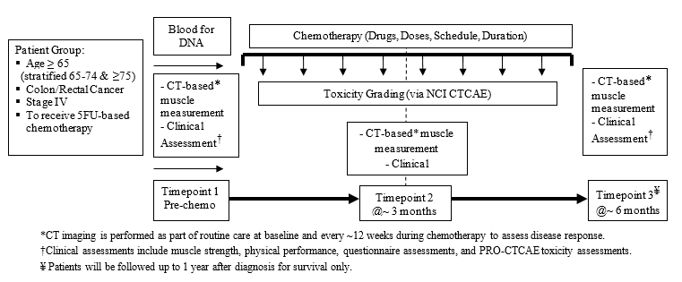

  - Interested? Email NCORP@wakehealth.edu for a start-up packet now!

  - The FAQ document for this study was revised on January 31, 2020 and has been posted on the WAKE NCORP website.

- WF 1802 PCW – Influence of Primary Treatment for Prostate Cancer on Work Experience
  - The Moderate to High Income, White stratum is nearing closure with less than 5 slots remaining.
  - You can determine the remaining slots left for any stratum by going to CTSU-OPEN -> Slot Reservation -> Report. Please see screenshot below.
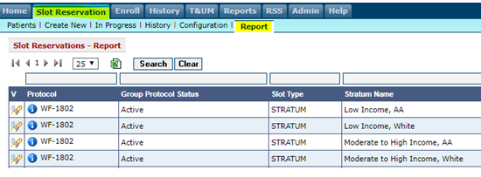
  - This study compares changes in work ability reported by African American and white prostate cancer survivors with higher and lower incomes. If you would like for the Wake Forest Health Equity Core team to contact you regarding ideas to help increase recruitment of African American and low income participants, please email NCORP@wakehealth.edu.
- WF 98213 PREVENT – Preventing Anthracycline Cardiovascular Toxicity with Statins
  - Reminder for those that may have patients coming back in for their 24 month follow-up, please make sure to schedule, remind your patients of this important visit, collect the data and send data into NCORP@wakehealth.edu .

REDCap Data Queries…AKA “Resolve Issues”
Please remember to click the “Resolve Issues” button in REDCap on the toolbar on the left side in the Applications section to see if you have any data queries.

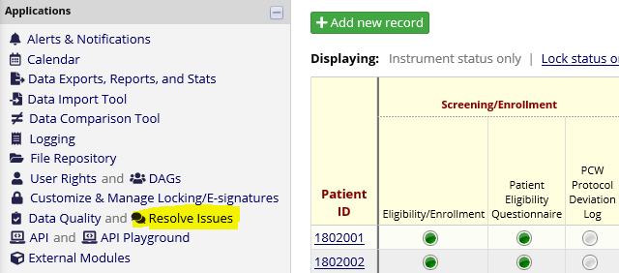

General Site email address: If your site has a general email address that you would like for WF NCORP RB to use in order to assure that your site gets all of the Bi-Weekly and Special Broadcasts, please send that email along with your site name and CTEP ID to NCORP@wakehealth.edu.

General Biospecimen Lab Management:
- Please request your lab kits before you run completely out of kits. This will ensure that there will be no delay in getting samples shipped to the Biospecimen Laboratory.

- Please do not ship samples on Thursday or Friday so that samples do not arrive on a weekend.

- Accruals as of February 14, 2020

Open Studies | Name | Enrolled | Target
WF 97115 | Acupuncture | 209 | 240
WF 97116 | Remember | 242 | 276
WF 97415 | Upbeat | 245 | 1000
WF 10217 | Ways | 206 | 220
WF 1801 | Ramipril | 26 | 75
WF 1802 | PCW | 68 | 220
WF 20817CD | OaSiS | 1,076 | 1114
WF 30917CD | Telehealth | 30 | 90
WF 1803CD | Caregivers | 611 | 828
WF 1804CD | AH-HA | 0 | 624
WF 1806 | M&M | 12 | 300
EAQ161CD | Biomarker Survey | 54 | 201

