Wake Forest NCORP Research Base
Bi-Weekly Broadcast
February 4, 2020
WAKE NCORP Website link https://wakencorp.phs.wakehealth.edu/

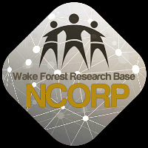

McKesson Alert:
Inclement Weather & Potential Impact CRS Operations
Clinical Research Services (CRS) in Irving, TX is currently under a winter storm watch for Wednesday, February 5, 2020. Current forecasts indicate the possibility for severe winter weather and icy conditions. Depending on the severity of the storm there is a potential for operational impacts resulting in delivery delays on Thursday, February 6.
We advise sites to place any critical orders that are needed for the remainder of the week as early as possible today, Tuesday February 5.
As weather is unpredictable, we will continue to closely monitor the storm and notify you of any further updates.
If you have questions regarding the shipment schedule, please contact our Clinical Research Services team at 800.693.4906, or via email at clinicalresearchservices@mckesson.com.

NEW TRAVEL AWARDS FOR PRIORITY ACCRUALS in 2020:
The Wake Forest NCORP Research Base will offer travel awards to cover two nights hotel accommodations at the Wake Forest NCORP 2020 Annual Meeting for NCORP Community and M/U Community sites that accrue the highest number of racial/ethnic minority and rural patients for each study below. Two travel awards per study will be offered for each of the following protocols:
- TELEHEALTH: WF 30917CD (all accruals between 1/1/2020 and 8/31/2020)
- PCW: WF 1802 (all accruals to AA and/or low-income strata between 1/1/2020 and 8/31/2020)
- WAYS: WF 10217 (all accruals between 1/1/2020 and 8/31/2020)

General Data Management: Queries for studies in REDCap – Please remember to click the “Resolve Issues” button in REDCap on the toolbar on the left side in the Applications section to see if you have any data queries.

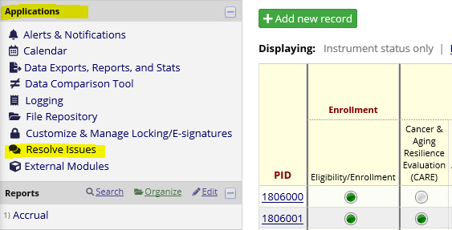

General Biospecimen Lab Management:
- Please request your lab kits from the Biospecimen Lab by emailing at 7NCORP@wakehealth.edu and Cc NCORP@wakehealth.edu or order through REDCap before you run completely out of kits. This will ensure that there will be no delay in getting samples shipped to the Biospecimen Laboratory.
- Please do not ship samples on Thursday or Friday so that samples do not arrive on a weekend.

STUDY UPDATES:

- NEW – WF 1805CD HN Star – Implementation and Effectiveness Trial of HN-STAR
  - An Introductory WebEx will be held February 25 at 3pm. Invitations will be sent shortly but please mark your calendars for this important WebEx which will describe the study in detail.

- WF 20817CD OaSiS – Implementation of Smoking Cessation Services within NCI NCORP Community Sites with Organized Lung Cancer Screening Programs
  - We are pleased to announce OaSiS is in its final year of data collection. During the 6 month survey, patients who self-report that they have not smoked for the last 7 days will be flagged to receive a saliva testing kit as the primary outcome of the study. We are asking for your help to increase the saliva kit returns. Below are some updates/ideas to help the OaSiS team gather this valuable data:
    - When a participant reports successful quitting at 6 months, tell them that they will get a saliva kit delivered to their home and field any questions. Encourage them to complete the saliva kit. This will help orient them to the process and what is coming in the mail. If any participant has further questions, have them reach out to the project manager, Rebecca Stone (336-716-6201; rjstone@wakehealth.edu).
    - Wake Forest NCORP team will notify site personnel when the kits are shipped and will be sending follow-up queries at 10, 20, and 30 days after the kit is shipped to the participant. NCORP staff will let you know whether or not we have received the kit. Please follow-up with the participant at these time points to make sure they have received the kit, to field any questions, or to confirm the mailed return of the saliva kit. Remind participants that all participants who return the saliva kits will be mailed a $20 gift card.
    - The OaSiS team will be sending monthly emails to your NCORP site team updating you on your return rates. Please be on the lookout for this communication.
  - Thank you for your help to increase saliva kit returns – your efforts are appreciated!

- WF 1801 Ramipril – A Single Arm, Pilot Study of Ramipril for Preventing Radiation-Induced Cognitive Decline in Glioblastoma (GBM) Patients Receiving Brain Radiotherapy
  - Chemotherapy drugs should not be reported on the concomitant medications form in REDCap. There is a place to report if all temozolomide was taken as prescribed for that time period on the weekly assessments during titration and during Radiation Therapy (RT).

- WF 1806 M&M – Myopenia and Mechanisms of Chemotherapy Toxicity in Older Adults with Colorectal Cancer.
Looking for a study for older patients? What about Spanish speaking patients?

Who can participate?
  - Older adults (age ≥ 65y) with either
    - Newly diagnosed metastatic CRC or
    - newly recognized metastatic recurrence of CRC greater than 1 year from completion of treatment for non-metastatic CRC
  - Planning to undergo 1st line 5-FU based chemotherapy as monotherapy or combination.
What is involved?
  - 3 Time points: Baseline, Time point 1 & Time point 2
  - Capturing data on routine treatment, labs & Grade 3 or higher Toxicities.
  - Brief physical testing – SPPB and HGS
  - Patient will complete paper surveys at each timepoint (approx. 20 mins)
  - Submission of patient blood for DNA markers & routine CT images
  - Survival status captured at 1 year from diagnosis
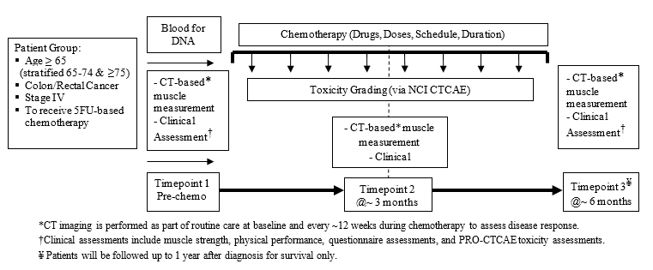

  - Interested? Email NCORP@wakehealth.edu for a start-up packet now!

  - The FAQ document for this study was revised on January 31, 2020 and has been posted on the WAKE NCORP website.

- WF 1802 PCW – Influence of Primary Treatment for Prostate Cancer on Work Experience
  - This study compares changes in work ability reported by African American and white prostate cancer survivors with higher and lower incomes. If you would like for the Wake Forest Health Equity Core team to contact you regarding ideas to help increase recruitment of African American and low income participants, please email NCORP@wakehealth.edu.

- WF 98213 PREVENT – Preventing Anthracycline Cardiovascular Toxicity with Statins
  - Reminder for those that may have patients coming back in for their 24 month follow-up, please make sure to schedule, remind your patients of this important visit, collect the data and send data into NCORP@wakehealth.edu .

General Site email address: If your site has a general email address that you would like for WF NCORP RB to use in order to assure that your site gets all of the Bi-Weekly and Special Broadcasts, please send that email along with your site name and CTEP ID to NCORP@wakehealth.edu.

- Accruals as of January 31, 2020

Open Studies | Name | Enrolled | Target
WF 97115 | Acupuncture | 207 | 240
WF 97116 | Remember | 239 | 276
WF 97415 | Upbeat | 242 | 1000
WF 10217 | Ways | 206 | 220
WF 1801 | Ramipril | 23 | 75
WF 1802 | PCW | 64 | 220
WF 20817CD | OaSiS | 1,060 | 1114
WF 30917CD | Telehealth | 29 | 90
WF 1803CD | Caregivers | 526 | 828
WF 1804CD | AH-HA | 0 | 624
WF 1806 | M&M | 10 | 300
EAQ161CD | Biomarker Survey | 49 | 201

