Wake Forest NCORP Research Base
Bi-Weekly Broadcast
January 14, 2021
WAKE NCORP Website: https://wakencorp.phs.wakehealth.edu/

ANNOUNCEMENTS

WF NCORP RB OFFICE CLOSURE: The office will be closed Monday, January 18, 2021 in observance of the MLK holiday. Will resume regular business hours on Tuesday, January 19, 2021.

Wake Forest Biospecimen Laboratory Closure: The lab will be closed Monday, January 18, 2021.
- Please do not ship samples on Fridays, as no one will be present to receive them in the lab on the weekends or that following Monday.

Drug Shipments from McKesson:
McKesson Specialty Distribution Centers will be open for business as usual on Martin Luther King Jr. Day, Monday, January 18, 2021. Please keep in mind that any orders placed on Friday, January 15 will be delivered on Monday, January 18.
Please do not place any orders on Friday, January 15 unless your practice will be open to accept deliveries on Monday, January 18, Martin Luther King Jr. Day. If you have any questions, please contact Customer Care at 800.482.6700.

COMMITTEE MEETING UPDATE – Change in date:
**Please note** There will be an initial meeting for those interested in our WF NCORP Community Health Equity Committee on January 25 @ 1pm EST. All providers and staff are invited to participate in this committee. If you are interested in this WebEx meeting, please email NCORP@wakehealth.edu so you may be forwarded the meeting invitation.

WAKE NCORP WEBSITE UPDATE:

When accessing the Wake NCORP Website (https://wakencorp.phs.wakehealth.edu/) please use the Google Chrome browser (https://www.google.com/chrome/). Documents, guides, and training videos work best in this browser.

The Quarterly WF NCORP RB Site Call, held on January 13, 2021 has been posted to the WAKENCORP website. Updates to various protocols were covered along with the impact of COVID 19 and adjustments that have been made to some protocols to assist with recruitment and retention.

Information regarding CCDR Survey/Practice Level Data Collection Form
- Requires that each site complete this survey every two years if participating in CCDR studies (site specific not study specific)
- You will not be able to enroll CCDR participants in OPEN until you complete this survey.
- Form location: CTSU website > Resources > Researcher Resources > NCI Resources
  - #10: CCDR Survey
  - #11 and #12: Supplemental resources
- Once completed, upload to CTSU
- For further information, please contact your site’s Program Director at NCI

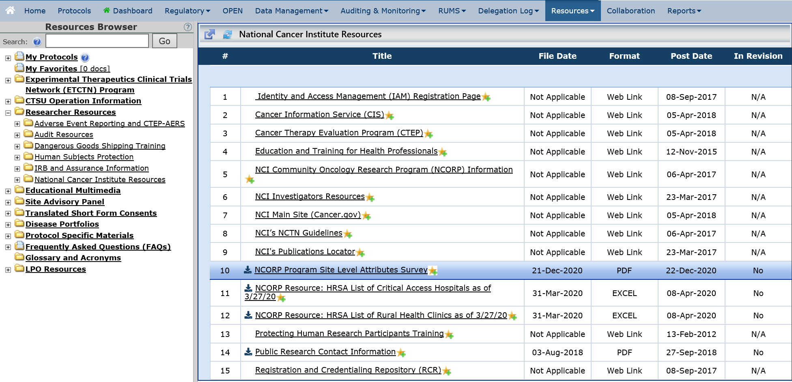

STUDY UPDATES:
- IMPACTS (WF-1901) Internet-delivered Management of Pain Among Cancer Treatment Survivors, Amendment 2, Protocol Version Date 08/01/2020

Helpful Guide document updated; v01.11.21. Added section with helpful tips for finding eligible patients.
The Helpful Guide and other supplemental resources are available on the WAKENCORP website.
A site call for this study was held on January 13, 2021. The presentation will be posted to the WAKENCORP website.
If there are any questions regarding the WF-1901 activation or site registration procedures, please contact NCORP@wakehealth.edu; Attn: WF-1901.

- WF 30917 Telehealth – A Stepped-Care Telehealth Approach to Treat Distress in Cancer Survivors
  - Amendment 5 has been approved and was activated on January 13, 2021.
  - There was a site call on January 11, 2021 at 4 PM EST to review the changes to the protocol in amendment 5. This site call presentation has been posted to the WAKENCORP website. These changes include:
    - Opening the study up to non-rural participants
    - Adjustments to the consenting process to make it more streamlined
    - Study is limited to those participants living in the following states: California, Georgia, Illinois, Kansas, Michigan, Minnesota, Missouri, New Mexico, North Carolina, North Dakota, South Carolina, Tennessee, Virginia and Wisconsin.

If there are any questions regarding the WF-30917CD, please contact NCORP@wakehealth.edu.

- Accruals as of January 13, 2021

Open Studies | Name | Enrolled (Patients) | Target (Patients) | Enrolled (Non-Patients) | Target (Non-Patients)
WF-97115 | Acupuncture | 222 | 240
WF-97116 | Remember | 268 | 276
WF-97415 | Upbeat | 287 | 1000
WF-1801 | Ramipril | 37 | 75
WF-1802 | PCW | 90 | 220
WF-1806 | M&M | 30 | 300
WF-1901 | IMPACTS | 0 | 456 | 0 | 40
WF-30917CD | Telehealth | 43 | 90
WF-1804CD | AH-HA | 21 | 600 | 5 | 40
WF-1805CD | HN STAR | 0 | 350 | 20 | 140

