Wake Forest NCORP Research Base
Bi-Weekly Broadcast
February 10, 2021
WAKE NCORP Website: https://wakencorp.phs.wakehealth.edu/

ANNOUNCEMENTS

TRAVEL AWARDS FOR 2021 ANNUAL MEETING!
We need your help! We are making one final push to successfully complete WF 30917CD, the Telehealth study and meet our goal of 90 participants by 9/17/21. To add a little bit of competitive motivation, we are offering two travel awards to cover two nights hotel accommodations at the Wake Forest NCORP 2021 Annual Meeting (The Renaissance Hotel, Asheville, NC) to the two highest accruing sites for all Telehealth accruals between 2/11/2021 – 9/1/2021.
Upcoming Meetings
Wake Forest NCORP Research Base Health Equity Core April 15, 2021 @ 3pm EST
Wake Forest NCORP Research Base Quarterly Site Call May 12, 2021 @ 3pm EST

2021 Annual Meeting: 10/3/21 – 10/5/21 at The Renaissance, Asheville, NC
2022 Annual Meeting: 10/9/22 – 10/11/22 at The Marriott Grand Dunes, Myrtle Beach, SC

WAKE NCORP WEBSITE UPDATE:

When accessing the Wake NCORP Website (https://wakencorp.phs.wakehealth.edu/) please use the Google Chrome browser (https://www.google.com/chrome/). Documents, guides, and training videos work best in this browser.

Study Updates

- WF-1801 Ramipril - A Single Arm, Pilot Study of Ramipril for Preventing Radiation-Induced Cognitive Decline in Glioblastoma (GBM) Patients Receiving Brain Radiotherapy
  - Amendment #5 was released Monday, February 1, 2021. Changes with this amendment include:
  - Off Study/Off Agent Form was separated into two different forms and the protocol sections that refer to these documents were updated.
  - The shipping address for samples for DNA isolation was updated.
  - A Special Broadcast was distributed when the amendment was released. If there are any questions regarding WF-1801, please contact NCORP@wakehealth.edu. Attn: WF-1801

An important reminder regarding which Adverse Events (AEs) should be reported and which should not be reported per the current approved WF-1801 protocol.
    - Grade 1 and 2 AEs will not be collected.
    - All expected AEs grade 3 and unexpected that are unrelated or unlikely AEs grade 3 will also not be collected.
    - All expected AEs grade 4 will also not be collected.
    - All other adverse events will be reported to the Wake Forest NCORP Research Base using REDCap Adverse Event Reporting and CTEP-AERS, if required per protocol. Please refer to Section 10.0 of the current approved protocol, which includes this table below for additional details.

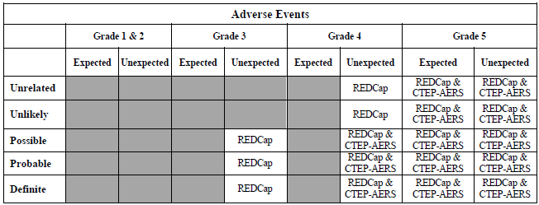

- For studies using REDCap data entry, please check and address any open data queries, at least weekly, by clicking the “Resolve Issues” link on the left side menu:

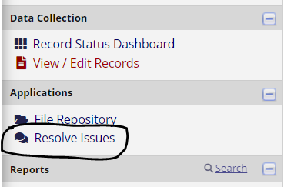

- WF-1804 AH-HA – Assessing Effectiveness and Implementation of an EHR Tool to Assess Hearth Health Among Survivors (AH-HA)

  - Changes have been made to the AH-HA Data Collection Webinar for the intervention arm (slide 37) to include the query upload information. These slides can be found on the WAKE NCORP website (DASHBOARDProtocol Documents1804-CD AH-HAWebinars).
  - The next AH-HA Site Call will be February 8, 2021 at 11:00 am EST.

- WF-1805 HN-STAR – Implementation and Effectiveness Trial of HN-STAR

  - Changes have been made to the Data Collection Training Slides for both HN-STAR (slides 15 and 17) and Usual Care (slides 13-14) arms regarding the “Send Survey” button. These slides can be found on the WAKE NCORP website (DASHBOARDProtocol Documents1805-CD HN-STARTrainings).
  - The next HN-STAR Site Call will be March 17, 2021 at 3 PM EST.

- Accruals as of February 9, 2021

Open Studies | Name | Enrolled (Patients) | Target (Patients) | Enrolled (Non-Patients) | Target (Non-Patients)
WF-97115 | Acupuncture | 224 | 240
WF-97116 | Remember | 270 | 276
WF-97415 | Upbeat | 297 | 1000
WF-1801 | Ramipril | 38 | 75
WF-1802 | PCW | 92 | 220
WF-1806 | M&M | 31 | 300
WF-1901 | IMPACTS | 0 | 456 | 0 | 40
WF-30917CD | Telehealth | 43 | 90
WF-1804CD | AH-HA | 40 | 600 | 5 | 40
WF-1805CD | HN STAR | 1 | 350 | 24 | 140

