Wake Forest NCORP Research Base
Bi-Weekly Broadcast
July 2, 2019

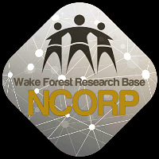

- The Wake Forest NCORP 6th Annual meeting will be held November 14 – 16 in Greenville, SC at the Hyatt Regency. You may begin making your hotel reservations by clicking on the following link https://www.hyatt.com/en-US/group-booking/GSPRG/G-NCOR [hyatt.com] a block of rooms have been reserved for this meeting. Tip: There is a Clemson/Wake football game this weekend so please be advised to grab your rooms early as all hotels in the area will fill fast. Registration link coming soon. The link for registration will be coming shortly.

- WF NCORP Research Base Office will be closed July 4, 2019 in observance of Independence Day. The WF NCORP Biospecimen Laboratory will also be closed on this date.

- McKesson – Clinical Research Services Closed July 4, 2019
  - In observance of Independence Day, McKesson’s Clinical Research Services will be closed Thursday, July 4, 2019. They will resume regular business hours on Friday, July 5, 2019.
  - Their regular business hours are Monday through Friday, 9 am to 6 pm ET.
  - Please take this information into consideration when placing your orders prior to Independence Day.
    - Only non-refrigerated product will be shipped on Wednesday, July 3. Orders placed prior to 2pm ET will be delivered on Friday, July 5.
    - If refrigerated or temperature-controlled product is required before the holiday, orders must be placed by Tuesday, July 2 prior to 2pm ET.
  - Due to the influx of shipments around the holidays, carrier delays may occur. Please plan your orders accordingly.
  - If you have any questions regarding the shipment schedule, please contact Clinical Research Services team at 800-693-4906 or via email at clinicalresearchservices@mckesson.com

- WF 1802 PCW – Influence of Primary Treatment for Prostate Cancer on Work Experience (PCW) study was activated on June 4, 2019. This study will compare changes in work ability reported by African American and white prostate cancer survivors.

  - Our first site call will be held on July 16, 2019 from 1:30-2:00; future site calls will be held bi-monthly. Site call meeting invitations will be distributed this week to sites who expressed interest in participating in this study.

  - In addition, the FAQ document has been updated with questions/answers from the June 12 training webinar. The document is posted on the WAKE NCORP website.
If you have any questions or would like more information, email NCORP@wakehealth.edu.

- WF 98213 PREVENT Study Cards
The Certificate study card that is given to participants upon completion of the study has been reformatted to an editable PDF to allow coordinators the freedom to type the participant’s name and date on the certificate prior to printing. A screen shot of the template is shown below. These templates can be found on the WAKENCORP website under Open Protocols | Prevent | Study Card Templates.
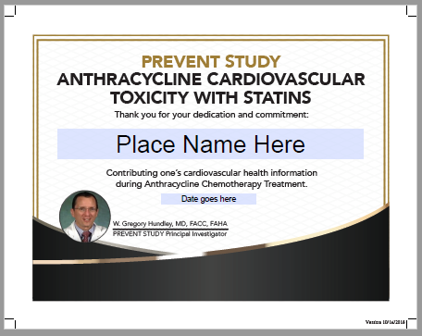

If you have any questions, please email NCORP@wakehealth.edu.

- WF 97115 – Acupuncture
  - Amendment 12 has been approved and will be active July 9, 2019. You will need to obtain your local IRB approval and send to NCORP@wakehealth.edu. Minor changes were made which include:
    - Exclusion criteria 2 was revised to account for participants who have had one submandibular gland removed as addressed in inclusion criteria 7.
    - The consent form was updated to include required language from the NCI informed consent template.
    - Patient Recruitment Flyer was created.
    - All documents will be posted on the Wake NCORP website next week.

- Accruals as of 6/30/19

Open Studies | Name | Enrolled | Target
WF 01213 | Relax | 46 | 75
WF 97115 | Acupuncture | 185 | 240
WF 97116 | Remember | 187 | 276
WF 97415 | Upbeat | 185 | 1000
WF 10217 | Ways | 207 | 220
WF 1801 | Ramipril | 6 | 75
WF 1802 | Prostate | 0 | 220
WF 20817CD | OaSiS | 768 | 1114
WF 30917CD | Telehealth | 14 | 90
WF 1803CD | Caregivers | 277 | 828
WF 1804CD | AH-HA | 0 | 624
EAQ161CD | Biomarker Survey | 53 | 201

